# Christopher Hyde

# Southern New Hampshire University

# IT-415: Advanced Info Systems Design

# Final Project - Prompt II

# Project Plan and Systems Design

# 10/20/2019

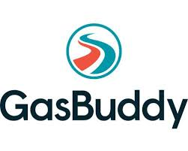

**Table of Contents**

**I. Project Plan**

Work Breakdown Structure Page 3

Timeline Page 4-5

Dependencies Page 5

Use of Tools Page 5

**II.** **System Design Document**

Introduction Page 6

Requirements Page 7

Constraints Page 8

Resources Page 9

System Overview Page 10

Documented Detailed Design Page 11-13

**I. Project Plan**

**Work Breakdown Structure**

The Work Breakdown Structure (WBS) is a hierarchal breakdown of the tasks required to complete a project by providing a roadmap for planning and scheduling. This is accomplished by dividing it up into smaller deliverable packages. By putting them in a logical form it assures nothing gets missed, helps with resource allocation, cost estimates, and provides an ideal tool for the team to work with. The project consists of six phases:

**Phase 1 (Research Phase)** - The project team is assigned its members, the scope of the project is defined, the requirements for the project and the costs associated with them are put together. The risks involved in the project are also identified in a risk matrix specifying the potential severity of those risks.

**Phase 2 (Design Phase)** - Here is where any hardware and software necessary for the project is gathered. This can vary depending on deliveries from the respective vendors. From there, the new app is designed, and the software build is configured.

**Phase 3 (Development Phase)** – In this phase the back-end and front-end changes take place.

**Phase 4 (Testing Phase)** - This includes software functionality, hardware, and upload/download speeds.

**Phase 5 (Implementation Phase**) - The coding and debugging of the mobile app site begins, it is uploaded, and then deployed to the public.

**Phase 6 (Maintenance Phase)** - Any customer issues with the new version are addressed, system maintenance is performed (as needed) and the entire process is documented from start to finish. (Markgraf, 2019).

The Gantt chart in Figure 1 on the following page depicts the entire detailed timeline.



**Timeline**

The timeline for the project will take place over a four-month period starting on Oct 1st and ending on Feb 3. There will be brief break s for the Thanksgiving and Christmas holidays but then the project will resume immediately after. This ensures that the momentum will not be lost and things stay on track. Each task is assigned a timeframe in days. While some tasks could take 1 day, others could take as much as 2 weeks. Keep in mind that these are estimates and there could be some variation in the length of these tasks should there be any unforeseen issues.

The most time-consuming parts of the project will be the Research, Design and Test phases, weighing in at about 3 to 4 weeks each.

**Dependencies**

Since we are using the Agile Methodology, there are not many dependencies. Due to the flexibility of this approach there are changes that can take place on-the-fly. Obviously, everything is dependent on the success and careful execution of the first two phases, the Research Phase and Design phases, to set the foundation. The front-end and back end development can take place simultaneously. The teams would then meet up again at the end to tie everything together. (De Los Angeles, 2018)

**Use of Tools**

For my Work Breakdown Structure, I am using Microsoft Visio and I am incorporating a timeline to the tasks involved. In doing so, I have created a Gantt Chart which lists all of the deliverables and the date ranges they cover. In the Gannt chart I break down the dependencies. Some require the task preceding it to be completed while other tasks or phases can be done in parallel to others. I chose Microsoft Visio for its ease of use. Microsoft Project is more elaborate (and costly) as it is an entire project management suite. However, it does require quite a bit of training.

**II. System Design**

**Introduction**

The developers at GasBuddy have been tasked with making enhancements to their mobile app that will improve performance, security and add new search features. This is necessary to ensure that the company maintains a sustainable and competitive advantage in the market. The System Design Document (SDD) acts as the architectural roadmap for the system. It describes the proposal put forth to upgrade GasBuddy to version 3.0. The enhancements involved in the redesign will be described in this document. The SDD will cover the requirements necessary to complete the project and include the requirements for the proposal. The constraints faced in meeting the goals such as time, resources, and budget are also covered. The necessary resources and the overall design will also be included. We will then look at the detailed design which will get down to the component level and document the tasks needed to accomplish the goal.

**Requirements**

From a deliverables standpoint, the project will ultimately result in some beneficial improvements that will vastly improve the business. These improvements are:

1. Top Tier Gas locations, price charts, and search filter
2. Charging Station locations, price charts and search filter
3. Fleet truck gas mileage dashboard
4. Cloud-based storage for users personal and credit card information

This will require modified page designs, revisions to front-end code, back-end code, and wireframes.

**Constraints**

As with any endeavor of this magnitude, there are constraints and risk factors to overcome. Mitigating those factors will greatly improve the success of the project.

**Data Security** - There is always the concern over data security. The confidentiality of the user’s credit card information as well as GasBuddy’s financial information is extremely important, particularly when the data is migrated to the cloud.

**Budget Constraints** - If the budget is underestimated, the funding could run out and the project could fail to meet expectations. Still, there are the unknowns that could arise and the budget should allow for some kind of a reserve funds.

**Time Constraints and Scheduling conflicts** - This can include scheduled vacations, sick days or employees simply being otherwise engaged in their daily tasks. In addition, the risk of scope creep is present in almost all projects. When requirements continue to be added to the project mid-stream, the size of the project has the potential to grows considerably from the original plan and take longer than first anticipated. It is paramount to stay on-point.

**Resources**

Resources will play a critical role in this project, both from a human resources standpoint as well as the hardware and software associated. The hardware aspect is of the project will be managed by Rackspace and will use an open source platform for the cloud-based software environment called Open stack. (Rackspace, 2019)

We will need a secure connection (SSD) when migrating the data to the cloud environment prior to production. Then it will be encrypted to Payment Card Industry Data Security Standards (PCI DSS) through Rackspace. The new app will continue to be compatible with the existing framework.

A dedicated team of GasBuddy personnel is also required to make this project succeed. At the heart of it all, if there isn’t 100% participation by everyone the upgrade has the potential of failure. With that in mind roles and responsibilities have been assigned as follows:

**Defined Project Roles**

**Role** **Name**

Project Manager Craig Daniels

Developer Laura Saunders

Analyst Rick Thompson

Software Tester Arnold Kapshaw

Hardware Tester Paul Jackson

Front End Developer Sarah Shea

Back end developer Bill Rinak

Exec. Management Tim O’Brien

**System Overview**

The new GasBuddy mobile ap (version 3.0) will have several improvements both from a security standpoint and in terms of the GUI (Graphic User Interface). The main screen will remain somewhat the same with slight changes to the color palette. The fleet truck dashboard will be added to the main menu options. Added filters will be put in place when searching for nearby gas. One will consist of a check box that when ticked by owners of electric vehicles, will show the charging location nearest to the user’s location. A second check box will have a selection for displaying Top Tier gas stations associated with the brand-name gas distributors like Mobile, Exxon, Sunoco etc.(Top Tier Gas, 2019) The user also has the ability to type in a zip code to locate charging stations and top tier gas within the selectable radius of that zip code. There will also be a selection on the menu to jump right to the search map using the user’s preferences.

Also, on the main menu there will be an added button for companies with fleets of trucks or delivery vehicles. They can click the button and sign-in to their business portal. This “dashboard” will display the location of their vehicles as well as fuel efficiency.

The last part of the system design will be relatively seamless to the user, but it is one of the most critical. It involves the security of the customer’s data. By moving to a cloud-based data storage model, sensitive information will safely be stored offsite. This will also offer the advantage of scalability as the business grows.

**Documented Detailed Design**

The end result of the newly designed app is depicted in the mockups below. Figure 2 shows the main screen with added icons for the Fleet Dashboard and Charging Station menu. Figure 3 is the Top Tier Gas and Charging Station search filters. Figure 4 is a representation of the map showing the location on charging stations in the nearby area.

(Fig. 2 Main Screen)

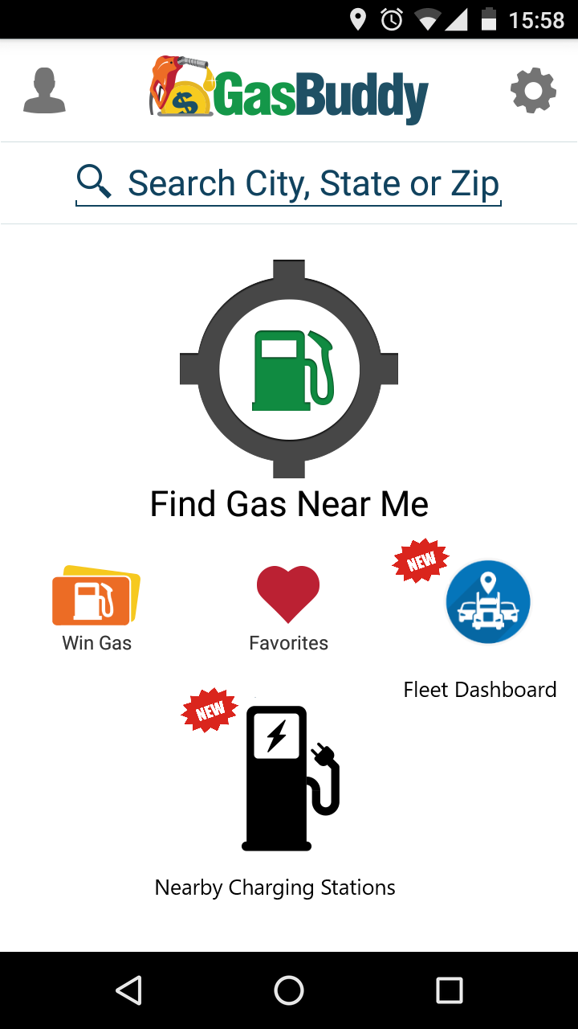

(Fig 3. Top Tier Gas and Charging Station Filters)

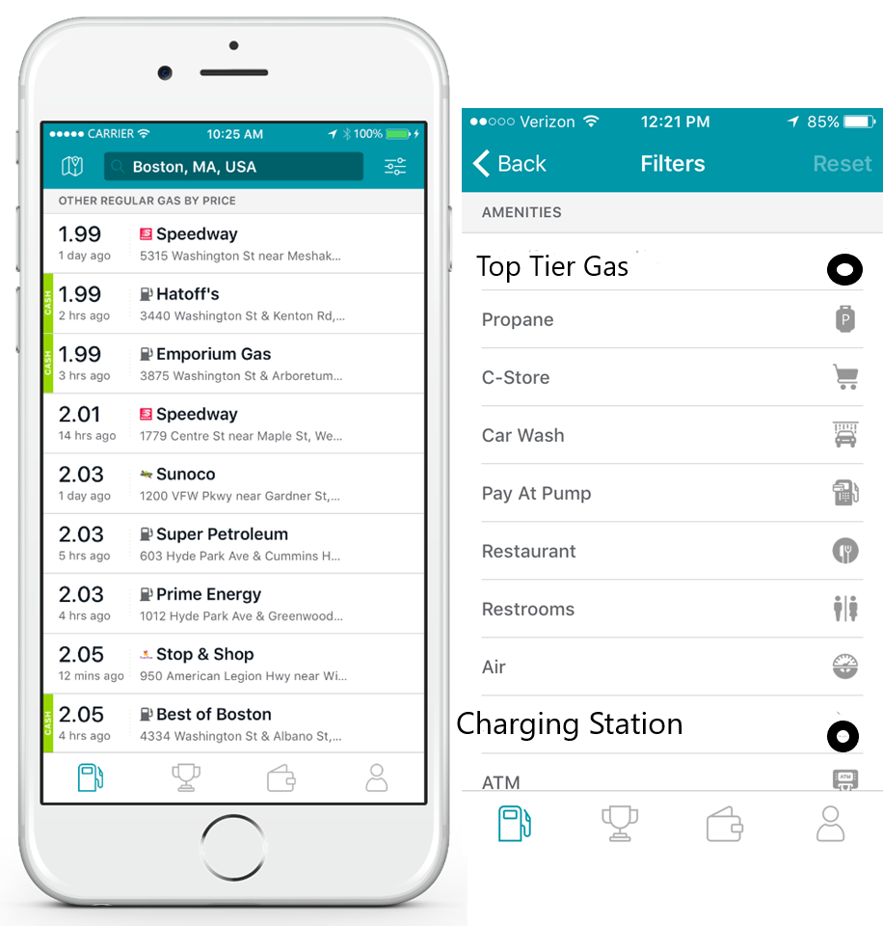

(Fig. 4 Charging Station Locations on Map)

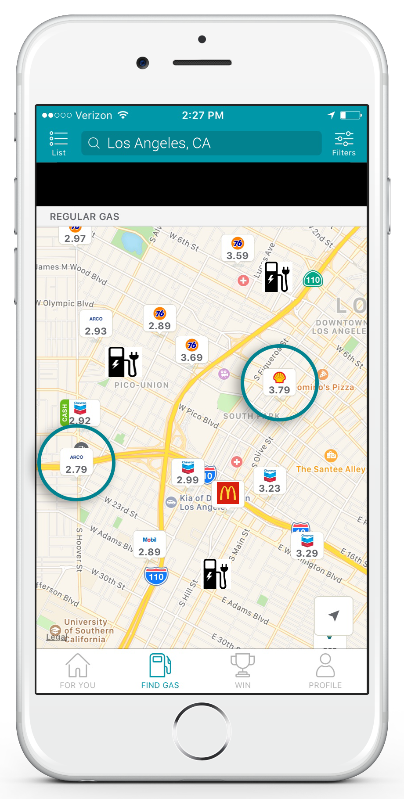

**References**

Huang, C.M. (2018). Gasbuddy: Fueling Its Digital Platform for Agility and Growth. *Harvard Business Publishing*. Retrieved from <https://hbsp.harvard.edu/download?url=%2Fcourses%2F635469%2Fitems%2FBAB420-PDF-ENG%2Fcontent&metadata=e30%3D>

# De Los Angeles, J (2018, March 19) Project Framework Comparisons: Agile vs. Waterfall vs. Hybrid vs. Lean. *Medium.com.* Retrieved from <https://medium.com/@jdelosangeles/project-framework-comparisons-agile-vs-waterfall-vs-hybrid-vs-lean-dc6801d217e4>

Markgraf, B (2019). The Advantages of WBS. *AZ Central.* Retrieved from <https://yourbusiness.azcentral.com/advantages-wbs-14178.html>

Top Tier Gas (2019). Top Tier Gasoline Brands. Retrieved from <https://www.toptiergas.com/licensed-brands/>

GasBuddy (2019). Image [GasBuddy Logo]. Retrieved from <https://www.gasbuddy.com/>

GasBuddy (2019). Image [GasBuddy Menu] Retrieved from https://www.gasbuddy.com/

Brown, S (2016, Nov 1). The Benefits and Challenges of Using OpenStack In Your Business. Rutter Networking Technologies Retrieved from https://www.rutter-net.com/blog/the-benefits-and-challenges-of-using-openstack-in-your-business

Rackspace (2019). Rackspace PCI Compliance. *Rackspace.com*. Retrieved from https://www.rackspace.com/en-us/compliance/pci